**Step1**: Creating **Schema/Tables**

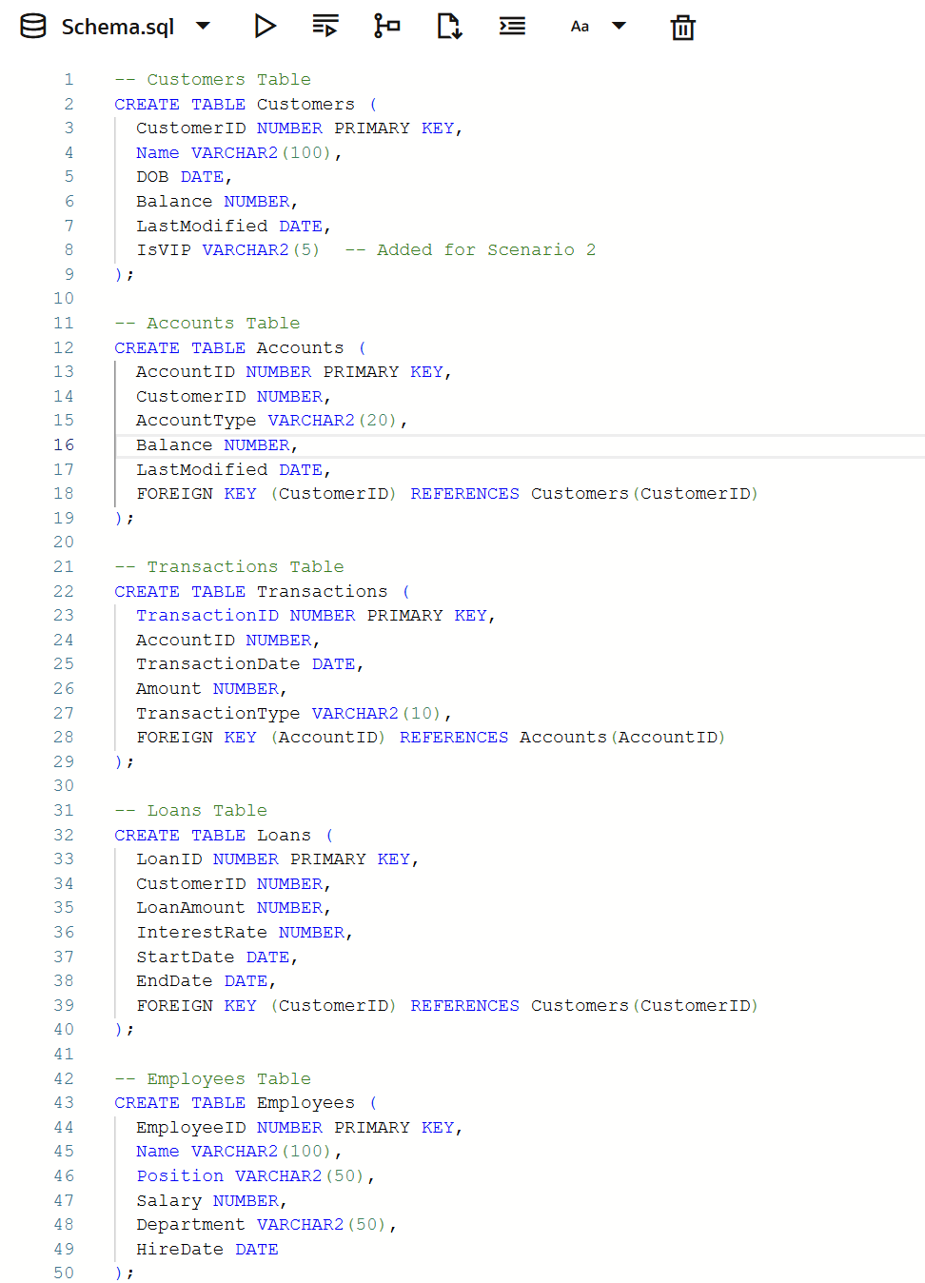



On the above created schema , operations for inserting and manipulating the data will be performed.